**PHP and MySQL**

## **Session 8 Practical:**

## **Db Connectivity and Testing**

## **Exercise 1**

The first exercise you create this week will generate a random set of lottery numbers. Create the script below and name it wk9ex1.php.



Run the script several times to check that the numbers generated are in fact random.

**RAN TWICE TO CHECK FOR RANDOM NUMBERS.**

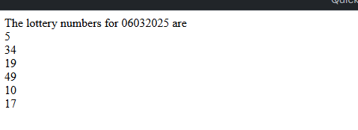

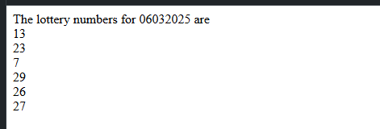

## **Exercise 2**

We will now create a table in which to store the numbers. Within your database, create the table with the following structure.

Remember that before you create the table you must first be logged into MySQL (phpMyAdmin) and have selected the database.

create table lotto ( wk int not null AUTO_INCREMENT,

lottodate date not null,

number1 int not null,

number2 int not null,

number3 int not null,

number4 int not null,

number5 int not null,

number6 int not null,

primary key(wk));

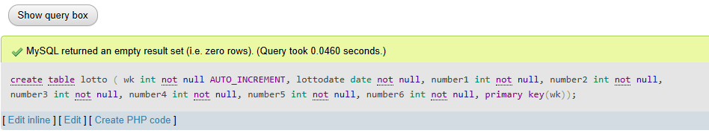

## **Exercise 3**

The original script wk9ex1.php will now be modified to allow us to save the numbers to the lotto table. Add the new statements, substituting your username, password and databasename in the appropriate places.



I had an error here, but that’s because I forgot to fill in the username password and database name. This shows how important it is to enter these details.

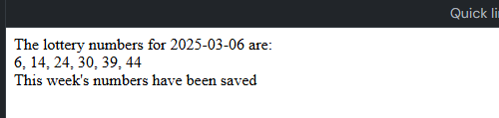

Run the script and check the values are being saved by logging into phpMyAdmin and viewing the data on the table (via the “Browse” tab).

SAVED LOTTO NUMBERS PROOF:

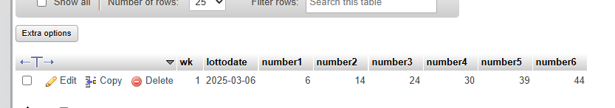

**Exercise 4.**

It would be useful to be able to look at previous lottery numbers. To achieve this we will write a new script that displays the lottery dates in a selection control. On selecting the date the script will display that dates numbers. Create the script below and save it as wk9ex4.php



Allows the user to be able to select the week of the lottery that’s been previously drawn.

Pressing show numbers displays the numbers.

Run the script to ensure it does display the lottery weeks within a selection box.

Finally we will add the code to display the numbers for the selected week. Modify wk9ex4.php in line with the script below.



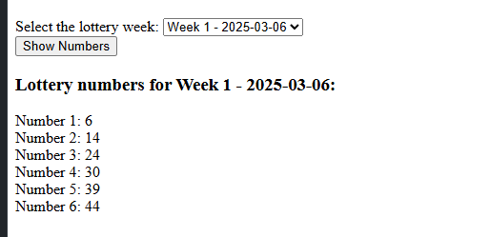

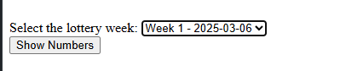

Allows the user to be able to select the week of the lottery that’s been previously drawn.

Shows a list of the numbers previously drawn.

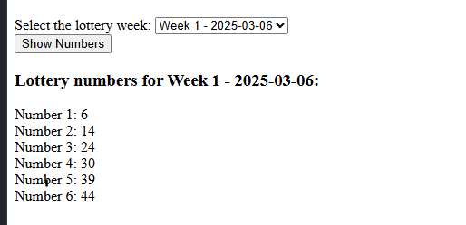

Run the script and check that the numbers displayed within the page correspond to the numbers in the table.

## **Exercise 5**

Draw the UML design for the script wk9ex4.php.

